HALF ADDER USING NAND GATE

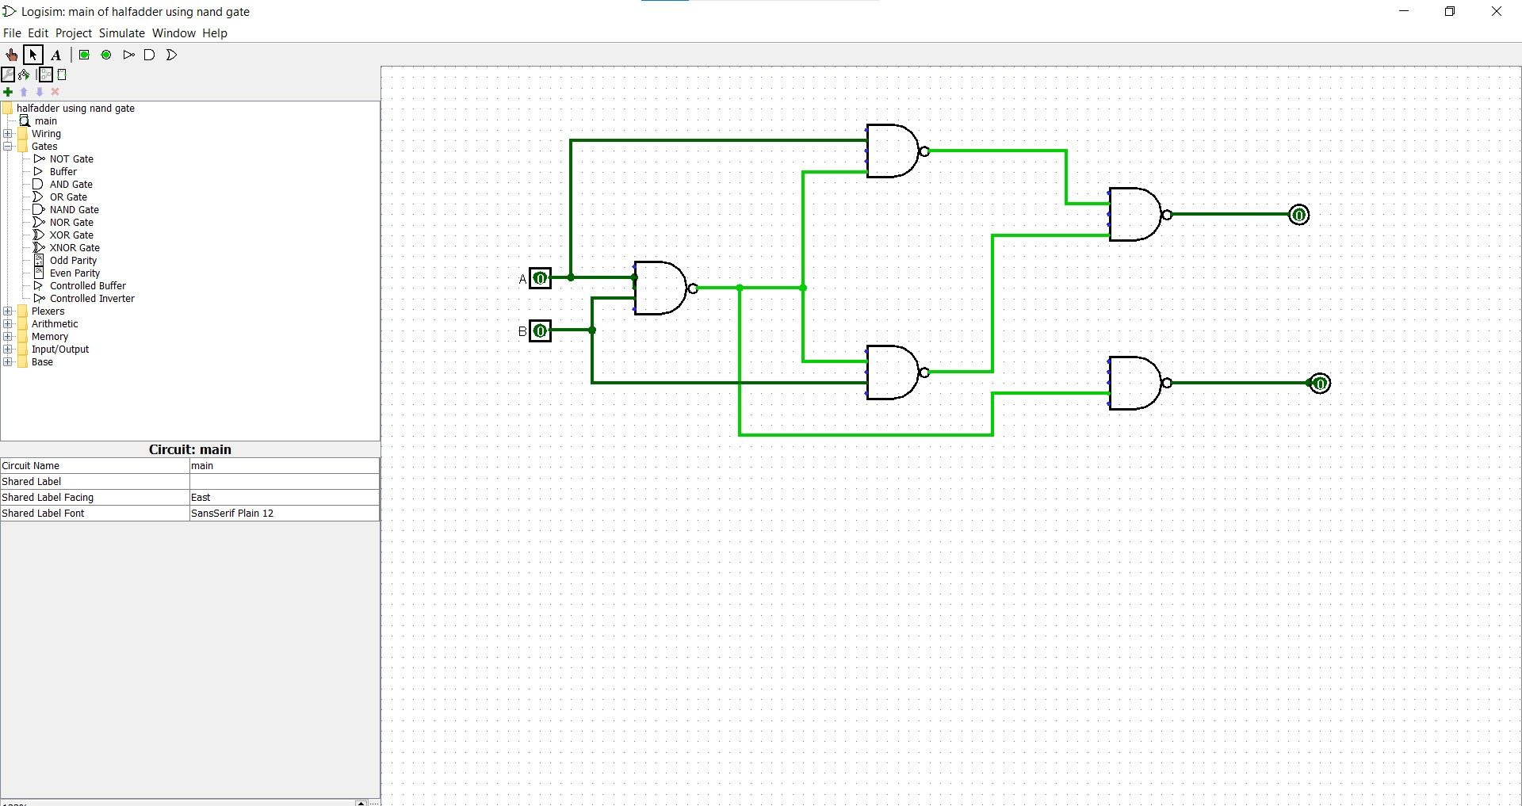S